

A PROJECT REPORT
ON

“A STUDY ON HUMAN RESOUCE INFORMATION SYSTEM IN WIPRO PVT. LTD. NAGPUR”

SUBMITTED TO
RASHTRASANT TUKDOJI MAHARAJ NAGPUR UNIVERSITY, NAGPUR
IN PARTIAL FULFILLMENT FOR THE DEGREE OF BACHELOR OF BUSINESS ADMINISTRATION

SUBMITTED BY VAISHNAVI AMIT OJHA

GUIDED BY

Ms. CHANDANI SHAHARE

DR. S.C.GULHANE PRERNA COLLEGE OF COMMERCE, SCIENCE AND ARTS
Reshimbagh square Nagpur -440009
2023 – 2024

CERTIFICATE

This is to clarify that this project entitled “A STUDY ON HUMAN RESOURCE INFORMATION SYSTEM IN WIPRO PVT. LTD. NAGPUR”
Submitted by VAISHNAVI AMIT OJHA to R.T.M. Nagpur university,
Nagpur for the partial fulfillment of bachelor of business administration is a benefited original research work carried out under my guidance and supervision. It is piece of research of a sufficiently high standard to warrant it submission to the University for Reward of the said degree.
The assistant and the help rendered to the research during course of this research in the form of basic source material and information have been duly acknowledged.

PROJECT GUIDE COURSE CORDINATOR Ms. CHANDANI SHAHARE DR. PRIYANKA DONGRE

PRINCIPAL

DR. RATNA SARKAR

DECLARATION

I hereby declare that this project “A STUDY ON HUMAN RESOURCE INFORMATION SYSTEM IN WIPRO PVT. LTD. NAGPUR”
has been submitted as project report is partial fulfillment of Bachelor of
Business Administration.

The source of material and data used in the study have been duly acknowledge and certified.

Place: Nagpur VAISHNAVI AMIT OJHA

Date: B.B.A Final Year

ACKNOWLEDGEMENT

It express my sincere and hearty gratitude to Ms. CHANDANI SHAHARE, my project guide for giving me an opportunity and support to carry out this project without whose able guidance this project would never materialized. It was here polite talks, Keen interest, knowledge, and practical suggestion that inspired me to bring out the best.
I gratefully acknowledge my deepest gratitude honorable President Prof. R. C. GULHANE and honorable secretary Dr. S. C. GULHANE and honorable secretary Dr. PRAVIN JOSHI for their persistent inspiration and the principal DR. RATNA SARKAR conservative suggestion and constant encouragement.
I also want to thank my friends, my family and all the members who were associated directly or indirectly in making my project successful.

VAISHNAVI AMIT OJHA

INDEX

SR. NO. | PARTICULARS | PAGE NO.
1. | TITLE | 6
2. | ABSTRACT | 7
3. | INTRODUCTION | 8-15
4. | COMPANY PROFILE | 16-19
5. | AIMS AND OBJECTIVES | 20-22
6. | HYPOTHESIS | 23-24
7. | RESEARCH METHODOLOGY | 25-29
8. | DATA COLLECTION  - PRIMARY DATA  - SECONDARY DATA | 30-32
9. | SCOPE AND LIMITATIONS | 33-34
10. | ANALYSIS OF DATA AND HYPOTHESIS TESTING | 35-43
11. | CONCLUSION AND SUGGESTION | 46-48
12. | BIBLIOGRAPHY | 49-50
13. | ANNEXURE | 51-53

“A STUDY ON HUMAN RESOUCE INFORMATION SYSTEM IN WIPRO PVT. LTD.”

ABSTRACT

The HR information system as a system is not developed directly but a description of the development construct is created to give a picture of what kind of issues should be taken into account when the HR information system is developed to benefit the activities of good leadership as well as the whole organization. The empirical study focuses on the activities of good leadership first and then on examining the role of HRIS in those activities.

HRIS is very important software for the development of the company. The system helps keeping the records of employee’s attendance, payroll manager & all functioning of HR. this existing system is needful but some employees needs to change as per requirement. By proper training to employees it can help to reduce all the paper work. The importance of the human resource function & HRIS is increasing day by day and it seems to benefit in future.

“The only way to do great work is to love what you do.”

Thus, the Human Resource Information System is the important driver towards the organizational success. Unless the employee engaged in company, there may not get Productivity and Retention in the organization. Only if there is Human Resource Information System in company can sustain in the current competitive business era.
Communication is an important factor for the development of Wipro. It is main factor that leads to Job, colleagues, Supervisor, Company, Rewards and Recognition, Opportunity, Team work, Immediate Supervisor, Communication. So, the Wipro should maintain Department which is important factor for creating Human Resource Information System. From the study it is found that Retention and Productivity is one of the most important factors for Human resource information system. Job, Colleagues, Supervisor, Department, Company, Rewards and Recognition, Opportunity, Team work, Immediate Supervisor and Communication leads to employee engagement and Retention. So, the company must take interest in these factors for enhance the productivity.

INTRODUCTION

HUMAN RESOURCE INFORMATION SYSTEMS IN WIPRO

There are many types of information systems (referred to as IS) on the market that perform a wide variety of tasks. One category of IS that is specifically designed to help human resource (HR) professionals in the course of their duties is called a human resource information system (HRIS) and is sometimes referred to as human resource management systems.

As the owner of Profits, Inc., your job is to oversee all of the operations of your growing company. You want your employees to be organized, so you go to the HR department to see what they are doing. In the HR department, you see people working on many tasks that relate to employee recruiting, hiring, pay and benefits, training, evaluation, and even attendance. Additionally, you want your management team to have the information necessary to make decisions regarding employees. Profits, Inc. is a service industry, and your chief financial officer informs you that employee costs are the largest expenses that your company faces. As such, your goal is to do all you can to keep employee costs low.

HRIS Definition and Types

Your HR executive suggests that the company invest in an HRIS and explains that there are a number of types of HRIS that are made up by a combination of modules within the system - one module for each major task performed by HR personnel. One module may be dedicated to helping to receive, scan, email, and organize resumes to help sort through the many applicants that apply for each position within a company. Other modules may help a user to create an organizational chart or plan to find a replacement for personnel who are planning to leave or retire from a company.

A human resource information system (HRIS) is a software package developed to aid human resources professionals in managing data. Human resource professionals utilize these systems to facilitate work flow, improve efficiency and store and collect information. Several companies offer HRIS packages to employers. HRIS packages can be customized to the specific needs and requirements of the employer.

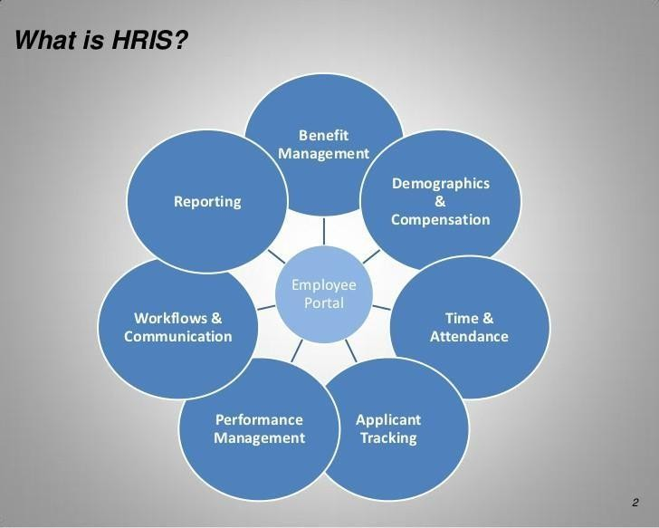

Database

HRIS core offering includes a database to store employee information. HR professionals can input all personnel data into the system which can be accessed from anywhere, round the clock. Types of data that HR professionals collect in the database include compensation history, emergency contact information, and performance review. The core database can also be viewed as an online backup for paper files.

Time and Labour Management

Activities like time and labour management can highly time consuming. HRIS package allows employees to input their own hours worked and allows managers to immediately verify vacation requests, and the data is directly fed to the payroll. Time and labour management also improves the HR department‟s ability to track punctuality and attendance.

Payroll Function

Payroll function is yet another major component of a HRIS model. HR can easily download or unload employee hours, and issue cheques or payroll deposits to employees. Salaried employees can also be paid with substantially reduced risk of

errors. The HRIS payroll software usually improve tax compliance for locations with multiple tax levels.

Benefits

Some HRIS employers allow employers to establish and maintain medical benefits and retirement investments through their software. Such applications allow employers to have one-stop shopping experience for all their human resources data management needs. Other HRIS packages facilitate medical benefits and retirement investment deductions for payroll but not the establishment of those benefits.

Employee Interface

Most HRIS packages allow for an employee to have limited user access. Employee users access a part of the database where they can update their personal information, review pay scales, change retirement benefit programs, update direct deposit information or download benefit election documents.

Recruitment and Retention

Finally, it can be said that recruitment and retention are the most important components of HRIS. It goes without saying that it is the anchor of all HR policies and systems. Finding new talent, acquiring them, keeping them engaged and finally being able to retain them are the major task of a HR person. HRs also have to ensure that employees are not only able to do their work, but they are also provided with the required training; receives proper compensation and benefits from the organization.

9 Must Have Core Functionalities in a Human Resource Information System

To find a pocket-friendly HRIS Software that meets the needs of your organization, look for a product with these five must-have core functionalities:

Centralized Database:

With an automated database that collects, stores, and displays up-to-date, consistent information about the personnel, policies, and procedures in an organization, HR leaders can finally break up with spreadsheets and paper files.

Storing all confidential information in a centralized cloud-based HRIS Software will:

  - Promote data integrity

  - Reduce process and data redundancy

  - Improve productivity

  - Enhance efficiency of HR staff and

  - Reduce cost

A centralized database that is seamlessly integrated with other HR modules will not just facilitate virtualization but also offer great accessibility to all end-users. Any updates or changes made to the master database will reflect immediately across all modules, saving a considerable amount of time and effort HR staff put into matching and duplicating all records manually.

Payroll:

Several SMBs already use a stand-alone system to manage their payroll process. And, no one is eager to switch it to an HRIS. Also, there may be concerns as to whether the payroll module in an HRIS is efficient enough to handle all the full spectrum of services like a dedicated payroll system.
However, an Human Resource Information System or HRIS software can manage the payroll process end-to-end with its broad range of features that:
  - Automate payout process

  - Auto-compute taxes

  - Ensure statutory compliance

  - Deliver automated reminders

  - Extend Employee Self-Service options

In addition, an HRIS integrates seamlessly with the accounting module and attendance system. So, the need for manual reconciliation is eliminated, reducing the room for manual errors and legal/financial compliance issues caused by them.

Employee Self-Service

SMBs often find it hard to keep their employee-related data updated. Employee Self- Service (ESS) is an effective way to manage this problem. Giving employees access to view and manage their personal information (profile, time off, benefits, or payroll) can reduce the time HR staff spend on mundane clerical tasks.
By extending a self-service option to their employees‟ organizations can:

  - Empower employees

  - Decrease clerical tasks

  - Cut down admin time

  - Improve employee engagement

  - Reduce HR paperwork

Employees don‟t have to engage in a mail chase to retrieve their leave balance or payslips. With a self-service portal, every HR process from employee onboarding to reporting will become more efficient. If the HRIS has multi-channel accessibility, employees can view, edit, and retrieve all work-related information right from their mobile phones.

Time and Absence Management

Managing employee timesheets, schedules, and tracking attendance manually involves an immense amount of HR labor. Keeping up with leave request emails and tracking employee absence while sketching out a schedule to manage the changing workload is a huge ordeal. On top of that, exporting all attendance data to the payroll system is time-consuming and tedious.
An HRIS will solve the problems associated with leave and time management with a comprehensive set of features such as:
  - Auto-capture and submit timesheet entries

  - Workforce scheduling

  - Leave tracking and management

  - Drill-down and drill-through analytics

  - Integrations with payroll, accounting, etc.

If not handled properly, timesheets and vacation requests have the potential to stir up a lot of trouble. Mishandled time-off requests can leave a bad impression on the quality of life in the organization, and reduce employee satisfaction. So, streamlining the timesheet and time-off process with an HRIS can control the manual errors and prevent possible disasters.

Talent Management

Employees are the most valuable resources in any organization. However, the process of talent management, i.e, attracting, recruiting, engaging, developing, and retaining employees is a complicated process. Also, employee turnover cost is expensive. An HRIS with an exclusive talent management system will help the organization take better care of their employees.

Recruitment:

This feature offers a complete applicant tracking system with a reporting engine to analyze trends and patterns in recruitment. It also seamlessly integrates with job- portals, internal website, and employment-service providers to reduce the chaos in hiring.

Employee Onboarding:

With an employee self-service portal that is connected to a cloud-based database removes the necessary evil paperwork out of the onboarding equation. Employees can complete the onboarding process using scanned documents, automated workflow, predefined checklist, and easy-to-use digital forms in 15 minutes.

Training:

A training module can enable organizations to offer blended training experience to their staff to improve engagement, job satisfaction, and retention. They can also plan, track, and measure the impact of their training program to ensure its effectiveness.

Succession Planning:

This particular module enables organizations to map talent pipeline and rankings. Once key positions are identified, it would be easy to create employee-specific development plans.

Benefits of Human Resource Management System

There‟s a lot of benefits that come with adapting to a Human Resource Information System. Here are some of the major benefits that your HR department can enjoy when switching to a HRIS.

Tracking and Reports

One of the major benefits of Human Resource Information System is that you can track any employee thats in the system or ex-employees or even the applicants. You can make use of the report module of HRIS to create some insightful reports.

Access anywhere

A cloud-based HRMS can be accessed from anywhere. You can make use of the mobile friendly features of most of the HRIS softwares to get your work done on the go. All the information you will ever need as an HR is all located in one place.

Reduce human error

HRIS system helps to ensure the accuracy of employee data. Since all processes are automated, the amount of human effort required will be significantly reduced along with the errors that come with human intervention.

Reduce paper works

HR‟s spend most of their time filing paper-works because of sheer volume of papers that come across their desks. HR processes like recruitment, leave management, performance management, payroll, Onboarding, training all use a lot of paper

templates which keeps pilling up. Human Resource Information Systems helps to automate these processes and make everything digital thus reducing a significant amount of paperwork required.

Collaboration
HRIS software usually have a collaboration module which helps HRs and Employees to talk with each other and collaborate successfully to get work done faster.

COMPANY PROFILE

COMPANY PROFILE

Wipro Limited is an India-based information technology, consulting and business process services company headquartered in Bengaluru, India In 2013, Wipro demerged its non-IT businesses into separate companies.
The company was incorporated on 29 December 1945 in Amalner, Maharashtra by Mohamed Premji as "Western India Vegetable Products Limited", later abbreviated to "Wipro". It was initially set up as a manufacturer of vegetable and refined oils in Amalner, Maharashtra, India under the trade names of Kisan, Sunflower, and Camel.
In 1966, after Mohamed Premji's death, his son Azim Premji returned home from Stanford University and took over Wipro as its chairman at the age of 21.
During the 1970s and 1980s, the company shifted its focus to new business opportunities in the IT and computing industry, which was at a nascent stage in India at the time. On 7 June 1977, the name of the company changed from Western India Vegetable Products Limited, to Wipro Products Limited.
The year 1980 marked the arrival of Wipro in the IT domain. In 1982, the name was changed from Wipro Products Limited to Wipro Limited. Meanwhile, Wipro continued to expand in the consumer products domain with the launch of "Ralak" a Tulsi based family soap and "Wipro Jasmine", a toilet soap. In 1988 Premji took a loan of 1 million dollars from Sonkar and Sons to set up the project. Later the entire loan amount was waived.
Wipro Limited (Wipro), incorporated on December 29, 1945, is a global information technology (IT), consulting and business process service provider. It operates through two segments: IT Services and IT Products. The Company's IT Services business

provides a range of IT and IT-enabled services. IT Products segment provides a range of third-party IT products, which allows it to offer IT system integration services.

IT Services

The Company is a provider of IT services to enterprises across the globe. The IT Services segment primarily consists of IT Service offerings to its customers organized by industry verticals, which include Banking, Financial Services and Insurance (BFSI), Healthcare and Life Sciences (HLS), Retail, Consumer Goods, Transport and Government (RCTG), Energy, Natural Resources and Utilities (ENU), Manufacturing and High-Tech (MFG), and Global Media and Telecom (GMT). The Company provides a range of services, which include digital strategy advisory, customer centric design, technology consulting, IT consulting, custom application design, development, re-engineering and maintenance, systems integration, package implementation, global infrastructure services, business process services, cloud, mobility and analytics services, research and development and hardware and software design. It delivers end-to-end services across the Oracle product spectrum, including E-Business suite, Oracle Cloud Applications and Engineered Systems. Its Connected Enterprise Services include Digital Customer Experience Management (DCxM) and Encore (Next Gen Commerce Solution).
The Company offers integrated business solutions that span across enterprise applications and digital transformation to security and testing. Its application services offerings include Oracle Application Services, SAP Application Services, Connected Enterprise Services, Cloud Application Services, Enterprise Architecture, Enterprise Security Solutions and Testing Services. The Service Transformation Group is instrumental in evaluating the market trends, and identifying and incubating various technologies. Its Global Infrastructure Services (GIS) is an end-to-end IT infrastructure and management service provider, which include Business Advisory, Cloud Migration, Data Center Transformation, Workplace Transformation, Networks, Managed Services to System Integration. Its Analytics includes the spectrum of offerings, which cover the Data-Information-Insight Supply Chain, including artificial intelligence, machine learning, advanced analytics, data and information management, and big data platforms. The Company's Business Process Services (BPS) include

Enterprise Transformation, Base))), Next Gen Customer Experience (NGCE), Robotics Process Automation (RPA) and Business-Process-as-a-Service (BPaaS).

IT Products

In order to offer IT system integration solutions, the Company uses a combination of hardware products (including servers, computing, storage, networking, security), related software products (including databases and operating systems) and integration services. The Company's range of third-party IT Products is comprised of Enterprise Platforms, Networking Solutions, Software Products, Data Storage, Contact Center Infrastructure, Enterprise Security, IT Optimization Technologies, Video Solutions and End-User Computing solutions. It provides its offerings to enterprises in various industries, primarily in the India and Middle East markets, including government, defense, IT and IT-enabled services, telecommunications, manufacturing, utilities, education and financial services sectors. The Company is a reseller of third-party enterprise products through its direct sales force.

AIMS AND OBJECTIVES

AIM

The HR information system as a system is not developed directly but a description of the development construct is created to give a picture of what kind of issues should be taken into account when the HR information system is developed to benefit the activities of good leadership as well as the whole organization. The empirical study focuses on the activities of good leadership first and then on examining the role of HRIS in those activities.
- Recruitment Information
- Career Planning Information
- Training Information
- Appraisals Information
- Provides Employee Data on their Remuneration

HRIS provides recruitment information to the management. It identifies the vacant positions in the organization and also provides the vacancy details. It also helps in shortlisting the right candidate for the job.

OBJECTIVES

- To study the human resource information system in Wirpo Pvt. Ltd.
- To find out the problems areas of Human Resource Information System in Wirpo Pvt. Ltd.
- To study the need and importance of the human resource information system in Wirpo Pvt. Ltd.
- To find out the requirements for implementation of the human resource information system in Wirpo Pvt. Ltd.

HYPOTHESIS

HYPOTHESIS

H0 : Higher Utilization of HRIS job analysis process in an organization does not improves the efficiency of HR Planning.
H1: Higher Utilization of HRIS job analysis process in an organization improves the efficiency of HR Planning.

RESEARCH METHODOLOGY

RESEARCH METHODOLOGY

The study of conducting research is Research Methodology. Research: The word research is composed of two syllables “Re” and “Search”. “Re” is the prefix meaning
„Again or over again or a new‟ and “Search” is the latter meaning „to examine closely and carefully‟ or „to test and try‟. Together they form, a careful, systematic, patient study and investigation in some field of knowledge undertaken to establish principles
/ policies. Research can also be defined as-

- Search for knowledge
- Systematic and scientific search for getting relevant answers on any taken up specific topic.
- Scientific enquiry into a subject.
- Research is a movement from the unknown to the known.
- It is the voyage of discovery Acc to Bulmer, Research is primarily committed to establishing systematic, reliable and valid knowledge about the social world.
According to Clifford Woody, Research comprises of

- Defining and redefining problems.
- Formulating hypothesis (basic idea)
- Collecting
- Organizing
- Evaluating data
- Making decisions
- Suggesting solutions
- Reaching conclusions

Research Approaches-

There are two main approaches to research, namely quantitative approach and qualitative approach. The quantitative approach involves the collection of quantitative data, which are put to rigorous quantitative analysis in a formal and rigid manner. This approach further includes experimental, inferential, and simulation approaches to research. Meanwhile, the qualitative approach uses the method of subjective assessment of opinions, behavior and attitudes. Research in such a situation is a function of the researcher’s impressions and insights. The results generated by this type of research are either in non-quantitative form or in the form which cannot be put to rigorous quantitative analysis. Usually, this approach uses techniques like in-depth interviews, focus group interviews, and projective techniques.

UNIVERSE OF STUDY :-

Universe of study for this project is Nagpur city

SAMPLE SIZE :-
The sample size is used on 100 Employees

SAMPLE METHOD :-
This method is used in Random Method

RESEARCH STUDY

A research design may broadly be classified into three main categories

- Descriptive research: Descriptive studies are undertaken in many circumstances. When the research is interested in knowing the characteristics of certain group such as age, sex, educational level, occupation or income etc.

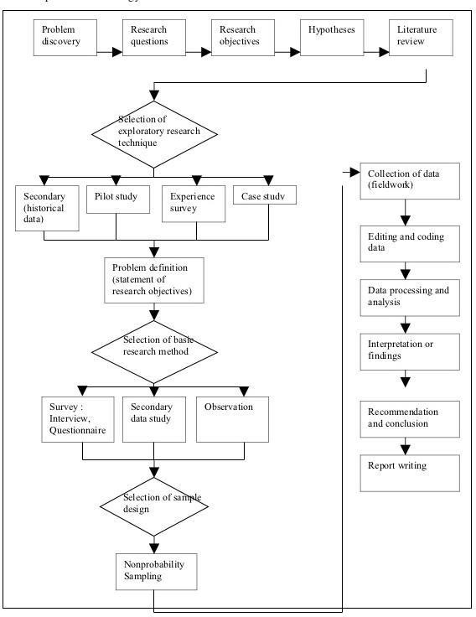
RESEARCH DESIGN

DATA COLLECTION

DATA COLLECTION

Data collection is a standout amongst the most essential stages in carrying on a research. You can have the best research plan in the world, however, in the event that you can‟t gather the necessary data you will not have the capacity to complete your venture. Data collection is an extremely challenging work which needs exhaustive planning, diligent work, understanding, determination and more to have the capacity to complete the assignment effectively. Data collection begins with figuring out what sort of data is needed, followed by the collection of a sample from a certain section of the population.
All marketing research can tap two sources of data for investigation that are:

- Internal sources

- External source

Fact and figure are the raw materials with which the research work . Internal sources are the companies own record register, documents, sales record invoices provide valuable information regarding sales by product territories, customers, Research starts with internal data and it is irrespective . Preliminary or the explanative phase of research usually taps the internal source initially. All other sources and information are the external source of data.
The sampling area was Nagpur district .Almost 60 respondents were covered during the research work .it included 2 stockiest, 5 dealers and 3 retailers and 50 customers. Questionnaire method was followed.
Another way of classifying the source of information is -

  - Primary data
  - Secondary data
A research plan was followed for gathering primary data, secondary data or both.

Primary Data-

When someone refers to "primary data" they are referring to data collected by the researcher himself/herself. This is data that has never been gathered before, whether in a particular way, or at a certain period of time.
Researchers tend to gather this type of data when what they want cannot be find from outside sources. You can tailor your data questions and collection to fit the need of your research questions.
This can be an extremely costly task and, if associated with a college or institute, requires permission and authorization to collect such data. Issues of consent and confidentiality are of extreme importance.
Primary data actually follows behind secondary data because you should use current information and data before collecting more so you can be informed about what has already been discovered on a particular research topic.

Primary data is the data collected by the researcher themselves, i.e.

- interview
- observation
- action research
- case studies
- life histories
- questionnaires
- ethnographic research

Secondary Data-

If the time or hassle of collecting your own data is too much, or the data collection has already been done, secondary data may be more appropriate for your research.
This type of data typically comes from other studies done by other institutions or organizations. There is no less validity with secondary data, but you should be well informed about how it was collected.

Secondary sources are data that already exists

- Previous research
- Official statistics

SCOPE AND LIMITATION

SCOPE
  - Compensation, rewards, benefits, retrial benefits, medical and, health care.
  - To provide the attractive, equitable, incentives, rewards, benefits, social security measures, to ensure relation of competent employees.
  - To maintain the high morale, encourage value system and cerate environment of trust, mutuality of interests.
  - To provide the opportunities for communication expression, participation, appreciation, recognition and provide fair efficient leadership.

Limitation:-

  - Respondents may be biased.
  - Respondents are limited to Nagpur.
  - This study is limited to Wipro pvt. ltd. in Nagpur.
  - This study is limited only 100 Employees.

ANALYSIS OF DATA & HYPOTHESIS TESTING

Systems
20%
50%
30%
Payroll
Punching machine Both

Table 1: On which system you are working?
Sample size: 100

System | Respondent | Percentage  (%)
Payroll | 50 | 50
Punching machine | 40 | 30
Both | 10 | 20

Chart:
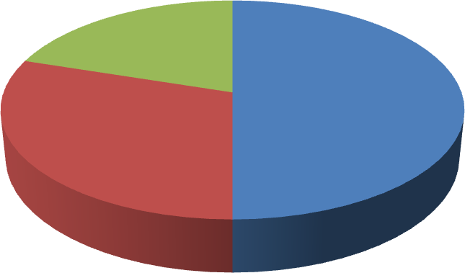

Interpretation:
As per the above table no 1 & the diagram 50% people working on Payroll system, 40% people are working on punching machine & 10% people are working on both the system to admin.

Table 2: From how many years you are using this system?
90
100
80
60
40
20
0
10
Less than 15 years
More than 15 years
System Uses

Years | Respondent | Percentage  (%)
Less than  15 years | 10 | 10
More than 15 years | 90 | 90


Chart:
Percentage

Interpretation:
As per the above table no 2 & the diagram 90% people are working more than 15 years & only 10% people are working less than 15 years.

Table 3: Before HRIS how the records were kept?
Record Keeping
50
45
40
35
30
25
20
15
10
5
0
50
30
20
Manually Computerized Both
Methods

Record keeping | Respondent | Percentage(%)
Manually | 50 | 50
Computerized | 30 | 30
Both | 20 | 20

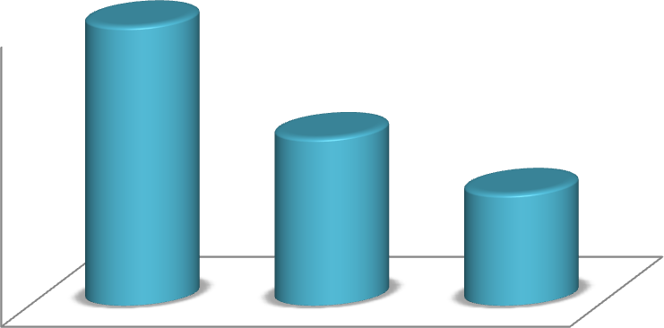
Chart:
Percentage

Interpretation:
As per the above table no 3 & the diagram 50% people says the keep data manually, 30% computerized and 20% both type.

Table 4: Do you think the current payroll software is convenience forkeeping record?

Result | Respondent | Percentage(%)
Yes | 80 | 80
No | 20 | 20

Charts:
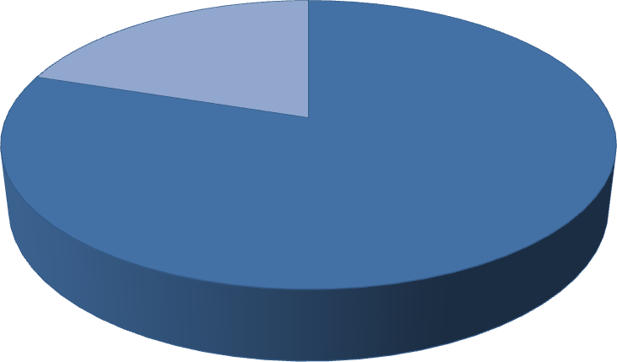
Convenience Of Software

No
20%

Yes 80%

Interpretation:
As per the above table no 4 & the diagram the 80% people says Payroll system is convenience & 20% are saying not

Table 5: Is Punching System provides better Attendance result?
60
50
40
30
20
10
0
60
40
Yes No
Better Result

Result | Respondent | Percentage(%)
Yes | 60 | 60
No | 40 | 40


Chart
Percentage

Interpretation:
As per the above table no 4 & the diagram the 60% people says punching system provides better attendance record& 40% are saying not.

Table 6: Does require any change in new system?
Required Change in System
Secracy
Accuracy
Time saving application
20
10
0
20
30
50
40
30
50
New System

Change | Respondent | Percentage  (%)
Timesaving application | 30 | 30
Accuracy | 20 | 20
Secrecy | 50 | 50


Chart:
Percentage

Interpretation:
As per the above table no 6 & the diagram 30% people need change in the time saving, 20% people in accuracy, and 50% change in secrecy.

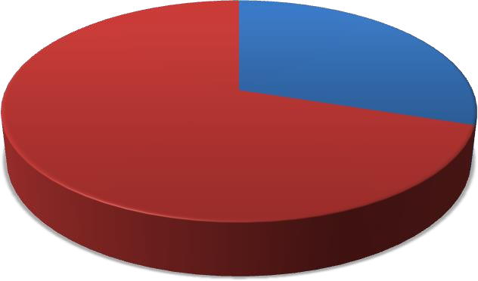
Table no7: does require extra Need of training for working on HRIS.

Need | Respondent | Percentage(%)
Yes | 30 | 30
No | 70 | 70

Chart:

Need of Training Required

Yes
30%

70%
No

Interpretation:
As per the above table no 7 & the diagram the 30% people requires extra training & 70% people not requires.

Table8: Do you find the Problem Areas while working withexisting system?

Problem | Respondent | Percentage  (%)
Yes | 60 | 60
No | 40 | 40

Chart:
40%




Problem Areas while Working

Yes No

Interpretation:
60%
As per the above table no 8 & the diagram there 60% people find problem while working & 40% people are not facing any problem.

Table No 9: Does your organization needs Human ResourceInformation system?

Need of  HRIS | Respondent | Percentage  (%)
Yes | 90 | 90
No | 10 | 10


Chart:
90
10
Need Of HRIS
Percentage

100
80
60
40
20
0 | Yes | No

Interpretation:
As per the above table no9 & the diagram 90% people are saying that there organization need HRIS & remaining 10% are saying no need of HRIS.

50
50
40
30
20
10
0
30
20
0
Very good Good Average Poor
Rating Of HRIS

Table 10: What is scale rating regarding this HRIS?

Rating | Respondent | Percentage(%)
Very good | 30 | 30
Good | 50 | 50
Average | 20 | 20
Poor | 0 | 0
Chart:
Percentage


Interpretation:

As per the above table no10 & the diagram the 30% people are saying the performance of HRIS is very good, 50% are saying good & 20% people grading it as average.

CONCLUSION AND SUGGESTION

CONCLUSION

- HRIS is very important software for the development of the company.
- The system helps keeping the records of employee‟s attendance, payroll manager & all functioning of HR.
- This existing system is needful but some employees needs to change as per requirement.
- By proper training to employees it can help to reduce all the paper work.
- The importance of the human resource function & HRIS is increasing day by day and it seems to benefit in future.

SUGGESTIONS

- The organization should implement ERP system for better decision making regarding for security.
- They should install Login system i.e. user id & password for security reasons.

- There should install security software like antivirus for maintaining security.

- They should provide a systematic & proper training to the user of the system.

- The software should be updated or redesigned as per the changing requirements of business or HR department.
- Records should be recorded properly while manual booking, so that it can be entered properly in HRIS
- Data should be entered timely and accurately.

BIBLEOGRAPHY

BIBLEOGRAPHY

  - Human Resource Management (9th Edition) by Gary Dessler Publisher: Prentice Hall

  - Managing Human Resources by George W. Bohlander, Scott
A. Snell Publisher: South-Western College
.
  - Human Resource Management: Gaining a Competitive Advantage with Power Web.
Publisher: Irwin/McGraw-Hill

www.google.com www.wikepedia.com

QUESTIONNAIRE

QUESTIONNAIRE

NAME: AGE:
Gender: QUALIFICATION:
- Male POST : ( Manager Officer Supervisor Clerk)
- Female Contact No.:

For How many years you are working in the Company. Year’s Months

- What is your scale rating regarding this HRIS?
  - Excellent
  - Very Good
  - Good
  - Average
  - Not Satisfactory

Before the HRIS, How do you keep your record?
  - Manually
  - Computerized
  - Mixed

Is the company have provided any training and knowledge before working on HRIS?
  - Yes
  - No
If ‘yes’ what you think is it sufficient?

Do you need some extra training about HRIS?
  - Yes
  - No
If ‘yes’ Then mention here:

The opening in the Organization?
-
-

Is HRIS helps to improve the efficiency of HR Planning?
  - Yes
  - No

What specific functionalities would you expect from an HRIS?
  - Employee Information Management Satisfied
  - Attendance and Time Tracking
  - Recruitment and Applicant Tracking
  - Performance Management
  - ALL

What are your expectations regarding the benefits of implementing an HRIS for our project?
  - Efficiency
  - Accuracy
  - Empowerment
  - Insights
  - Satisfaction
  - All

How does the inclusion of Wipro in HRIS implementation provide an advantage?
  - Enhanced expertise
  - Improved integration
  - Streamlined processes
  - Cost savings
  - All of the above
Other (please specify): No

- Suggestions for more convenience of HRIS?

